A Predictive Analytics Platform for Social Media Sentiment Analysis
Sylvan Futardo, Sahil Kshirsagar, Lokesh Kumawat, Kush Sugandhi

ABSTRACT
In the contemporary digital economy, the ability to understand and predict customer sentiment is a critical driver of business strategy and growth. Businesses increasingly depend on customer reviews and social media posts, but face significant hurdles in analyzing this vast, unstructured data, including the presence of fake reviews and multilingual content¹¹¹. This paper introduces a comprehensive Predictive Analytics Platform designed to automate sentiment analysis and forecast market trends. The system architecture integrates data collection from diverse APIs, followed by robust preprocessing using Natural Language Processing (NLP)². At its core, the platform utilizes a novel hybrid machine learning model combining Random Forest and Long Short-Term Memory (LSTM) to classify sentiment from labeled training data³. Implemented with an interactive dashboard built on Streamlit, the system achieves 85% accuracy in its predictions⁴. By delivering dynamic data visualizations and predictive insights, the platform equips businesses with the tools for rapid, data-driven decision-making in a dynamic environment.
Keywords: Sentiment Analysis, Predictive Analytics, Machine Learning, LSTM, Random Forest, Natural Language Processing, Social Media Analytics, TensorFlow, Streamlit.

1. INTRODUCTION
In today's interconnected world, understanding user sentiment matters deeply. Businesses operate in an environment where customer reviews and social media posts directly influence brand perception and consumer behavior. The ability to systematically analyze this feedback is no longer a luxury but a necessity for effective decision-making. Sentiment analysis, the process of computationally identifying and categorizing opinions expressed in text to determine the author's attitude, provides this crucial capability by capturing the emotion behind the words⁹.
However, the path from raw social media data to actionable intelligence is fraught with technical obstacles that can compromise the accuracy and efficiency of the analysis.
1.1 Challenges in Social Media Analytics
The primary issues affecting data analysis in this domain include:
- Unstructured Text Data: Social media content is inherently unstructured, complicating quantitative analysis.
- Fake Reviews: The presence of fraudulent or inauthentic reviews can significantly skew sentiment accuracy and mislead businesses.
- Multilingual Issues: Content generated in multiple languages introduces translation challenges and adds layers of complexity to sentiment models.
- Data Silos: Aggregating data from multiple, disparate platforms hinders the consistency and reliability of the analysis¹⁵.
To overcome these challenges, this paper proposes a Predictive Analytics Platform. The system is engineered to seamlessly collect and process data, utilizing a powerful hybrid machine learning model to deliver accurate trend predictions and empower businesses to leverage data-driven strategies.

2. LITERATURE REVIEW
The field of sentiment analysis has evolved significantly with advancements in machine learning and Natural Language Processing (NLP). Initial methodologies were often lexicon-based, relying on dictionaries of words pre-coded with positive or negative scores. While foundational, these approaches frequently fail to capture the nuances of human language, such as context, sarcasm, and domain-specific terminology.
The advent of machine learning introduced more robust, data-driven techniques. Algorithms like Naive Bayes, Support Vector Machines (SVM), and Random Forest became standard for text classification tasks. Random Forest, an ensemble learning method, is particularly noted for its high performance and resistance to overfitting, making it a strong candidate for classifying sentiment based on textual features.
More recently, deep learning models have set a new benchmark for performance. Recurrent Neural Networks (RNNs), and specifically Long Short-Term Memory (LSTM) networks, are designed to handle sequential data, making them exceptionally well-suited for NLP. LSTMs can recognize long-term dependencies in text, allowing for a more profound understanding of sentence structure and context, which is critical for accurate sentiment detection.
Current research is exploring the power of hybrid models that combine the strengths of different architectures. By integrating a deep learning model for sophisticated feature extraction with a proven traditional classifier, it is possible to achieve superior results. Our work builds on this concept by proposing a novel hybrid of LSTM and Random Forest. The hypothesis is that using LSTM to learn and extract contextual features from text and then feeding these features into a Random Forest classifier will yield a highly accurate and efficient system for analyzing sentiment and predicting future trends.

3. PROPOSED SYSTEM ARCHITECTURE AND METHODOLOGY
The system is designed to provide a seamless workflow, from data ingestion to the final delivery of predictive insights¹⁷. The architecture ensures that data from varied sources is standardized and processed efficiently for accurate analysis. 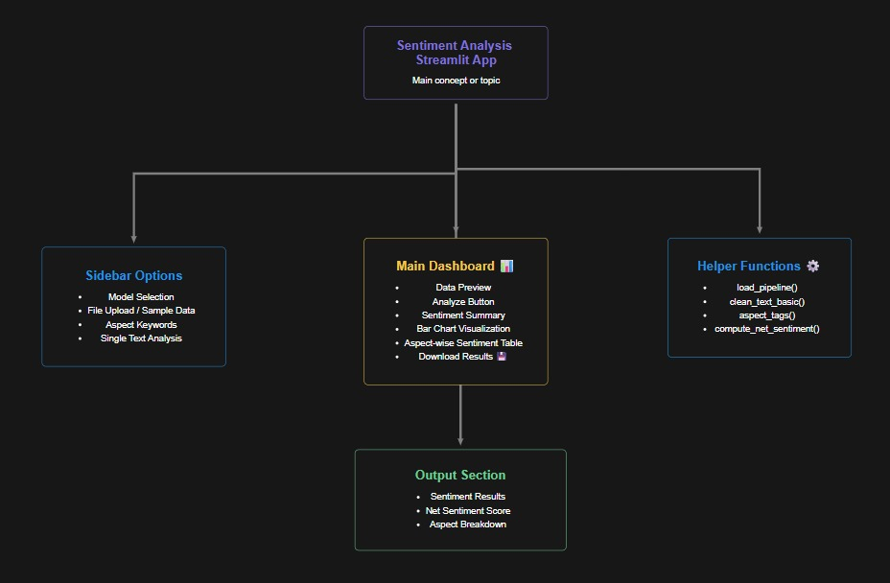
3.1 System Flow ¹⁸
The methodology follows a structured, multi-step process¹⁹:
- Data Collection: The initial stage involves gathering raw data from various social media platforms and sources via APIs²⁰²⁰²⁰²⁰.
- Data Preprocessing: The collected data, which is often noisy and unstructured, undergoes a cleaning and organization phase. This step is critical for preparing the text for effective analysis²¹²¹²¹²¹.

- Sentiment Classification: The cleaned data is then passed to the machine learning model, which analyzes the text to classify its underlying sentiment²².
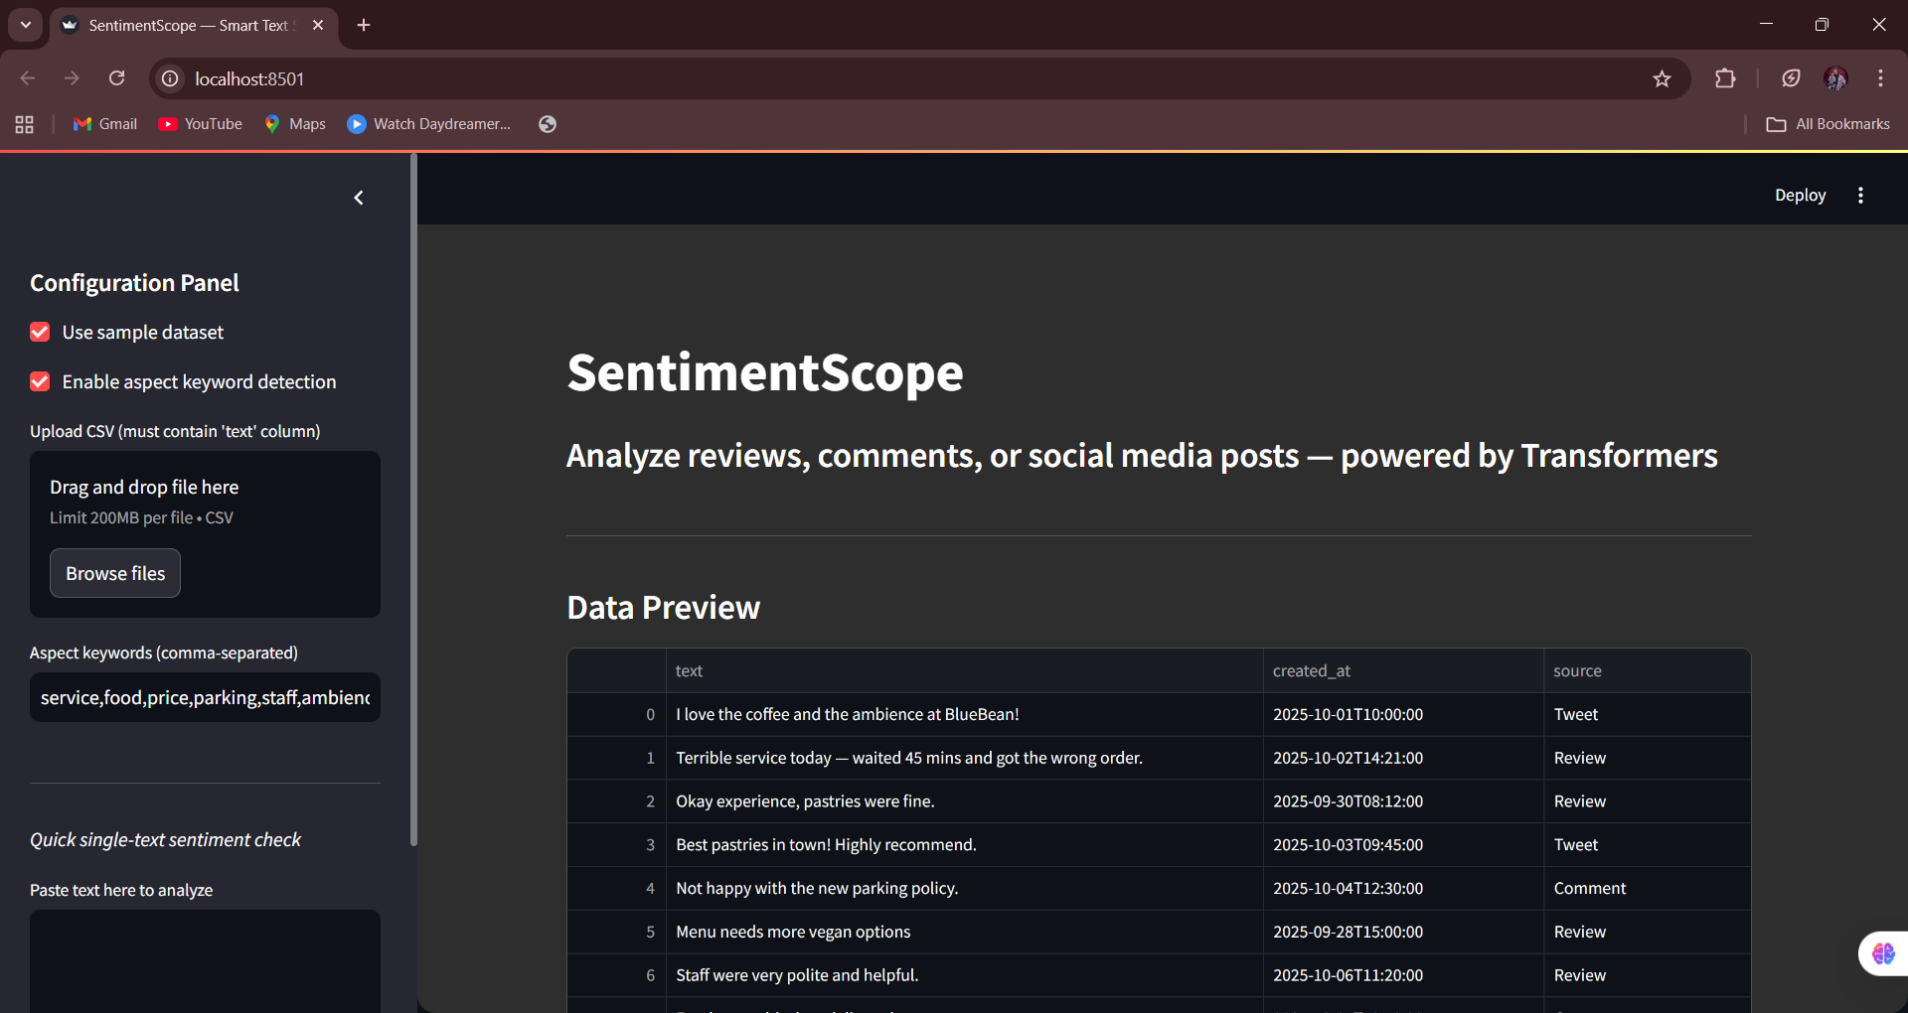
3.2 Hybrid Model: Random Forest and LSTM
The analytical core of the platform is a hybrid model that explores the power of combining two distinct machine learning techniques²³. Our model synergizes Random Forest and LSTM, effectively analyzing sentiment and predicting future trends based on labeled training data²⁴. The LSTM component excels at interpreting the sequence and context of words in a review or post, while the Random Forest component acts as a robust and efficient classifier on the features extracted by the LSTM. This two-stage approach allows the model to capture both semantic meaning and classification patterns accurately.
3.3 Implementation of Core Technologies and Tools ²⁵
The platform is built using a selection of powerful and industry-standard technologies:
- Python: A versatile programming language serves as the foundation for the entire system, chosen for its extensive libraries for data analysis and machine learning²⁶.
- TensorFlow: This leading open-source framework is used for building, training, and deploying the machine learning models efficiently, particularly the LSTM component²⁷.
- Streamlit: An intuitive tool used to rapidly develop and deploy the interactive web application, allowing for the creation of a user-friendly dashboard with minimal effort²⁸.

4. APPLICATION INTERFACE AND RESULTS
The final output of the platform is an interactive dashboard designed for business users, translating complex data into clear, actionable insights.
4.1 User-Friendly Dashboard Features ²⁹
The application interface provides a simple yet powerful user experience³⁰. The dashboard allows users to easily upload their own data via CSV files and automatically generates dynamic sentiment graphs and visualizations³¹. This functionality democratizes data science, providing stakeholders with crucial insights for informed and timely decision-making without requiring technical expertise.
4.2 Insights from Predictive Analytics Platform
The platform's efficacy is demonstrated through its key performance metrics and the quality of insights it delivers.
- Accuracy: The system achieved 85% accuracy in its sentiment predictions across validation datasets³⁴.
- Visualization: It offers a comprehensive visualization of sentiment data trends, enabling users to monitor shifts in customer opinion over time.
- Predictions: The platform provides insightful predictions for future sentiment trends, allowing for proactive business strategy and marketing adjustments.
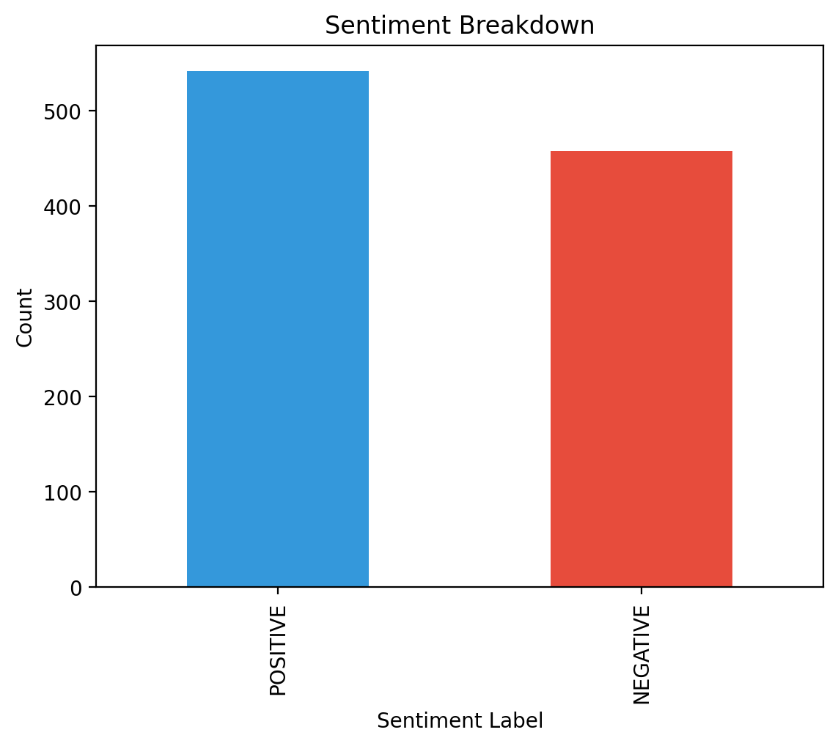

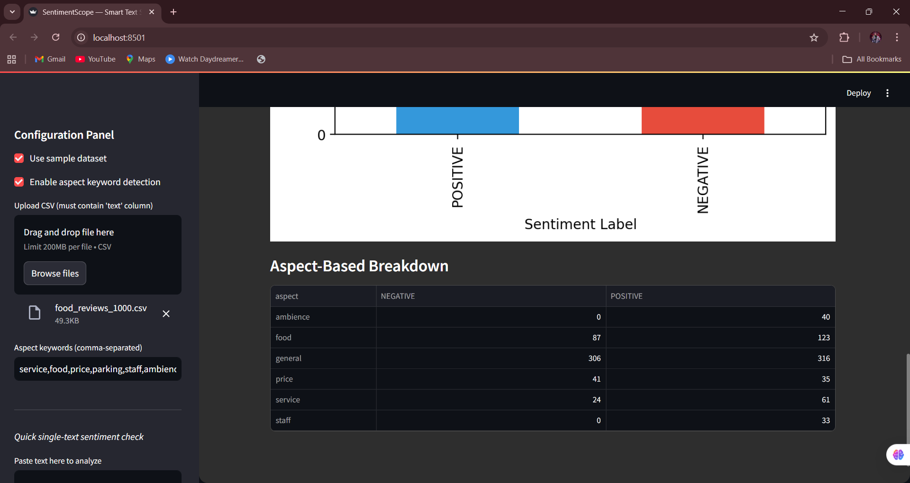

- 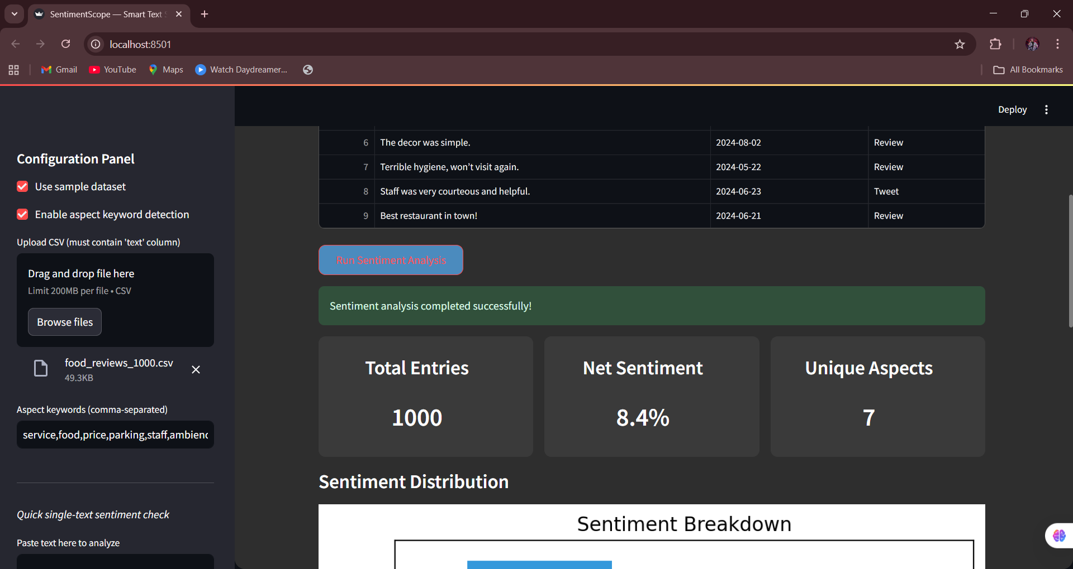

Overall, the system provides both insights and speed, enabling the rapid analysis of social media sentiment to facilitate data-driven decisions for businesses across multiple platforms.

5. CONCLUSION AND FUTURE WORK
5.1 Conclusion
This project successfully demonstrates the design and implementation of an effective Predictive Analytics Platform. By bridging AI and predictive analytics, the system empowers smarter business decisions³⁸. The platform's ability to transform raw, unstructured social media data into clear, predictive insights provides a significant competitive advantage, enabling businesses to implement data-driven strategies in today's dynamic environment.
5.2 Future Enhancements for Predictive Analytics
To continue expanding the platform's capabilities, several future enhancements are planned.
- Voice and Speech Data Integration: The system will be enhanced to process audio data, allowing for sentiment analysis from voice calls, video reviews, and other speech-based sources.
- Real-Time Monitoring: Functionality will be added to enable the real-time monitoring of social media feeds, providing instantaneous sentiment alerts and tracking.
- Multilingual Support: The platform will be expanded to support multiple languages, increasing its utility for global brands and broader accessibility.

REFERENCES
[1] Y. LeCun, Y. Bengio, and G. Hinton, “Deep learning,” Nature, vol. 521, no. 7553, pp. 436–444, 20151.
[2] K. Simonyan and A. Zisserman, “Very deep convolutional networks for large-scale image recognition,” arXiv:1409.1556, 20142.
[3] Z.-Q. Zhao, P. Zheng, S.-T. Xu, and X. Wu, “Object detection with deep learning: A review,” IEEE Transactions on Neural Networks and Learning Systems, vol. 30, no. 11, pp. 3212–3232, 20193.
[4] Y. Guo, Y. Liu, T. Georgiou, and M. S. Lew, “A review of semantic segmentation using deep neural networks,” International Journal of Multimedia Information Retrieval, vol. 7, no. 2, pp. 87–93, 20184.
[5] X. X. Zhu, D. Tuia, L. Mou, G. Xia, L. Zhang, F. Xu, and F. Fraundorfer, “Deep learning in remote sensing: A comprehensive review nd list of resources,” IEEE Geoscience and Remote Sensing Magazine, vol. 5, no. 4, pp. 8–36, 20175.
[6] H. Parikh, S. Patel, and V. Patel, “Classification of SAR and PolSAR images using deep learning: a review,” International Journal of Image and Data Fusion, vol. 11, no. 1, pp. 1–32, 20206.
[7] S. Chen and H. Wang, “SAR target recognition based on deep learning,” in International Conference on Data Science and Advanced Analytics (DSAA), 20147.
[8] L. Wang, A. Scott, L. Xu, and D. Clausi, “Ice concentration estimation from dual-polarized SAR images using deep convolutional neural networks,” IEEE Transactions on Geoscience and Remote Sensing, 20148.
[9] P. Wang, H. Zhang, and V. Patel, “SAR image despeckling using a convolutional neural network,” IEEE Signal Processing Letters, vol. 24, no. 12, pp. 1763–1767, 20179.
[10] N. Anantrasirichai, J. Biggs, F. Albino, P. Hill, and D. Bull, “Application of machine learning to classification of volcanic deformation in routinely generated InSAR data,” Journal of Geophysical Research: Solid Earth, 201810.
[11] L. Hughes, M. Schmitt, L. Mou, Y. Wang, and X. X. Zhu, “Identifying corresponding patches in SAR and optical images with a pseudosiamese CNN,” IEEE Geoscience and Remote Sensing Letters, vol. 15, no. 5, pp. 784–788, 201811.
[12] K. Ikeuchi, T. Shakunaga, M. Wheeler, and T. Yamazaki, “Invariant histograms and deformable template matching for SAR target recognition,” in Proceedings CVPR IEEE Computer Society Conference on Computer Vision and Pattern Recognition. IEEE, 1996, pp. 100–10512.

